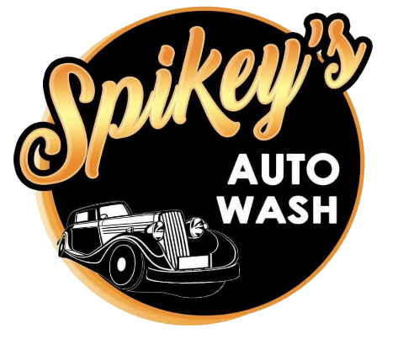

**Control Number: _______________**

LOYALTY CARD

**FREE WAX**

**FREE BODY WASH**

**Landline: (049)545-0359 / Mobile Number: 0917-8848886**

NAME & PLATE NO:

**FREE ARMOUR ALL**